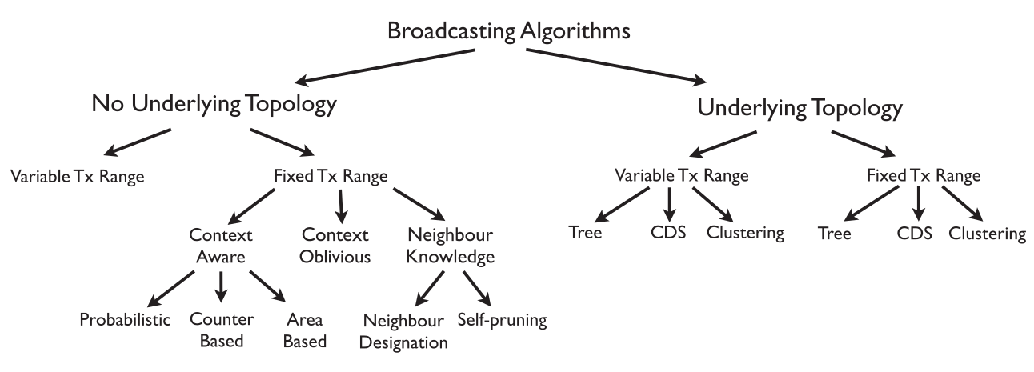

 | dist2mean | 2d - abba | MPR | CDS | EWMA | our
Number of nodes | N/A | 500 | 1024 | 20 to 100 step 10 (sparse)  100 to 1000 step 100 (dense) | 10, 30, 50, 100 | From 8 to 360
Definition of density | Number of nodes in transmission range | Network degree | N/A | Total number of node in the whole area | Total number of node in the whole area | Number of nodes in transmission range
density | 8, 10, 15, 20, 30 | 7,8,9, 10, 15, 20, …, 125 | N/A | N/a, we can guess | N/A | 2, 5, 10
How is generated the topology | Distributes nodes in one field of static size 400x400 | Randomly distributed nodes in area of 100x100. | Connected networks, square network region 32x32 | Randomly distributed in a 100x100 space. Connected network | distributed according to a spatial Poisson distribution over the same region | Randomny distributed in area of varying size to guarantee density
Number of topologies | N/A | 100 topologies for each density | 1 | 5 + 10 | 100*4 sizes*3 path loss * 3 algorithms | 10*3 densities*number of ratios tx/area (5 right now) = 150
Include mobility | NO | NO | NO | NO | NO | NO
Include dynamic transmission range | NO | NO | NO | NO | YES | NO
Include discussion on possible scenarios of use | VANET |  | Dynamic Environments or with high error rate, many nodes and dense networks | When the transmission range is small in relation to the area (see figure 7). An d it suppose to be good in the same scenarios that MPR | Yes, when the antenna can dynamically change its transmission range and the nodes are static | ?
Other protocols used for comparison | Location and distance | BPS with threshold of 0.4R and three versions of GeoFlood | Flooding | MPR and EMPR | BIP and MST | -
Tool used in evaluation | Broadcast Design and Analysis Tool | N/A | N/A | N/A | N/A | omnet
How is the source selected | The closest to the center | One randomly chosen node | All nodes, one at a time | - | randomly | One in the center
Radius of Transmission range | 10  for a ratio of 10/400 | N/A | N/A but it is fixed | Fixed 25 and 50 respectively | N/A | 120. for a ratio radius/area from 2 to 6
Number of Broadcast sessions | 1 | 1 per experiment | 1 per each node per experiment | - | N/A, maybe 1 | 300
Number of experiments | 30 for each density (30*5) | 100 for each density (100*18) |  | N/A (repeat the experiment a sufficient number of times to make 90% confidence interval within +-5%) | 100 for each simulation setup (netork of specific size, propagation loss exponent and algortihm) | 4 per topology per configuration
Threshold to consider a broadcast session as valid | 95% | N/A, probably 100% | 0%. They always measure other metrics | - | N/A | 100%, but only for broadcast time
What is the payload | N/A | N/A | N/A | - | - | A short sentence
Measure resources to build the topology | - | - | N/A | no | no | yes
Measure Coverage | yes | yes | Yes, number of nodes that received the packets | no | no | yes
Measure Broadcast Time | no | no | Yes (in clock ticks) | no | no | yes
Measure Power Consumption | no | no | no | no | Yes, total power of broadcast tree[25]. Use transmission power of d^alpha. Apparently no reception power | yes
Measure Network Bandwidth | Yes, using a metric called transmit density | Yes, average number of transmissions | Yes, how many nodes retransmitted the message. Also number of duplicated receptions | no | no | We use number of duplicated messages
Measure how long last the network activity | no | no | yes | no | no | no
Measure  Error rate | NO | N/A | No, it is a parameter of the experiment | no | no | no
Measure “Size” of the topology | - | - | no | Yes, it is the only thing they compare. | no | -
is collision considered? | NO | N/A | yes | no | no | Yes/no
Is fading considered? | NO | N/A | no | no | Yes (alpha) | no
How are results shown | Using charts | Discussing the average differences between protocols | Charts, the simulations consist in varying the probability of error from 0 to 100% and measuring different stuff | Charts with interval confidence | Charts with confident interval | Using charts

